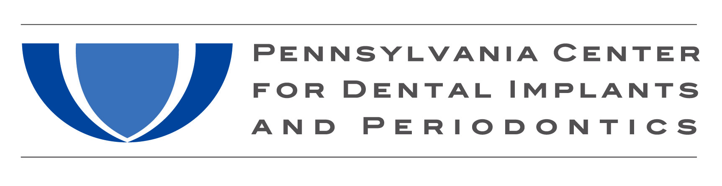
“All-On-4™” – The Fully Edentulous Patient Case:

Case Fees for “All-On-4™” are $24,400.00 for surgical fees, restorative fees, parts and a transitional and final single arch screw retained hybrid restoration.

The price break down is:
- Restorative office is paid $11,700.00, from this amount pays the lab fees of $4,700.00
- Dr. Levine’s or Dr. Fava’s surgical fees are $12,700.00; from this amount our office provides 4 impression copings, 6 temporary cylinders, 4 abutment replicas, 4 analogs and 4 final abutments

Additional Information:

- New Tech Dental Lab fees ($4,700.00 package price) includes an immediate denture, surgical dupe of denture, occlusal matrix, 48 hour processing of attachments, final milled titanium fixed hybrid, and night guard
- If a certain service or step is not involved due to the type of case (ex. no immediate load or denture conversion) that will be deducted from the package price
- Dr. Levine or Dr. Fava will decide if the total case fees include extractions or any additional surgical fees. This decision will be based on the difficulty of the case. The idea is: if it’s a simple surgical extraction case (very advanced periodontal disease with mobilities), additional fees may not be added. If the patient requires bone reconstruction or numerous surgical extractions, additional surgical fees will be added. Your office should inform the patient that there will be additional fees on top of the $24,400.00 due to the complicated nature of their case and final case fee will be determined by Dr. Levine or Dr. Fava so there are no misunderstandings
- Dr. Levine’s and Dr. Fava’s office will collect a 25% non-refundable deposit upon appointment reservation. After confirmation of payment, our office will send the restorative office $4,700.00 for lab fees. Full and final payment is collected the day of surgery. Upon receipt of final payment our office will send the balance of $7,000.00 to the restorative doctor.

Robert A. Levine, DDS, FPCC Philip L. Fava, DMD, MDSc
Email – rlevine@padentalimplants.com Email – pfaca@padentalimplants.com
Cell – (215) 990-0406 Cell – (631) 875-0922
Office – (215) 677-8686

Tami Vishio Paula Chernoff Barbara Irizarry
Office Manager Treatment Coordinator Treatment Coordinator
Drs. Robert Levine & Philip Fava Drs. Robert Levine & Philip Fava Drs. Robert Levine & Philip Fava
Email – tvishio@padentalimplants.com Email – pcharnoff@padentalimplants.com Email – birizarry@padentalimplants.com
Cell – (215) 407-3664 Cell – (215) 251-1213

Todd Hydock Amy Modlin
NewTech Dental Lab Straumann®, Territory Representative
Phone – (215) 699-8861 Cell – (267) 403-0100
Cell – (215) 262-1099 Email – amy.modlin@straumann.com
Email – todd@ndlsmile.com

9/2015

