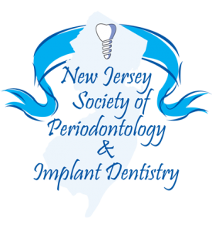

Annual Membership Dues for 2017

_______________________________________
Name

Office name
if different from above____________________________________

________________________________________________________
Address

___________________/________________________/____________
Office Phone Cell Phone Fax Number

_________________________________________________________
Email

______________________________/__________________________/_______________________________
Dental School / Date of Graduation Periodontal Program Date/Anticipated Date of Graduation

2017 NJSP&ID Dues: $110.00 per year

______ Enclosed is a check for NJSP&ID 2017 dues for $110.00

Make Checks Payable to: New Jersey Society of Periodontology & Implant Dentistry

Mail to:
New Jersey Society of Periodontology & Implant Dentistry (NJSP&ID)
Dr. Jane Ligums - Executive Secretary
P.O. Box 34, Gillette, NJ 07933
E-mail: jligums6@gmail.com

=============================================================

Dr. Nima Mirmadjlessi,
President- New Jersey Society of Periodontology and Implant Dentistry
Cell: 201-745-4231 Fax: 732-651-8033 E-mail: NMIRM@aol.com

Jane Ligums, DMD, FAGD
Executive Secretary
New Jersey Society of Periodontology & Implant Dentistry (NJSP&ID)
Office & Cell: (908) 581-4479 E-mail: jligums6@gmail.com www.njperio.org
P.O. Box 34, Gillette, NJ 07933

